Reproductive mechanisms underlying operation sex ratio variation in *Silene acaulis*

**Introduction**

Reproductive strategies in angiosperms are immensely diverse. Gynodioecy, a dioecious mating system with genetically controlled morphs that are either hermaphrodite or female. Hermaphrodite fitness is achieved by passing genes onto progeny through both pollen and seeds, while females only contribute to progeny via seeds; begging the question how are females maintained in a population? Gynodioecy is thought to arise by the introduction of mutations in either the nuclear or cytoplasmic DNA that confer male sterility and nuclear restorer genes that reintroduce hermaphroditism (Delph and Carroll 2001; Lloyd 1974). Male-sterility may be favorable in populations suffering inbreeding depression and vigorously invade a population (Charlesworth 1981). Negative frequency dependence in the form of pollen limitation and reduced female fertility then favors hermaphrodite morphs, which are reintroduced in a population due to mutations in nuclear DNA that restore male function. Balancing selection shifts the female and hermaphrodite frequency around an equilibrium sex ratio. If male sterility is inherited through cytoplasmic DNA, females must only have non-zero compensation to be maintained in a population, due to maternal cytoplasmic inheritance in angiosperms (Delph et al. 2007). Non-zero compensation in females is again accomplished through the avoidance of inbreeding by obligate outcrossing (Charlesworth and Charlesworth 1978) and reallocation of resources to increased flower and seed production (Asikainen and Mutikainen 2003; Morris and Doak 1998; Shykoff et al. 2003), more effectively producing gametes of one sex. However, balancing selection acts by suppressing female advantage through pollen limitation (Alonso 2005). While balancing selection maintains both females and hermaphrodites in a population, the ratio at which they are maintained is often highly variable.

Environmental factors can influence the reproductive success and potentially other vital rates of females and hermaphrodites to different extents. The operational sex ratio (OSR; proportion of hermaphrodites in a population) can serve as a snapshot of the relative advantage for females and hermaphrodites in the recent past. Yet, the mechanisms that drive sex ratio in a population are understudied. Variation in sex ratio can be attributed to many factors, such as resource competition, the underlying genetics of sex-determination, or demographic biases (Field et al. 2013). In terms of reproductive output, female vs hermaphrodite advantage depends on resource limitation, pollen limitation, inbreeding depression, and isolation from potential mates. When resources are limited, females have the advantage requiring fewer resources for female function. Pollen limitation or the lack of pollinator access severely disadvantages females in a population. Hermaphrodites in isolated locations or with limited access to pollinators have the advantage of pollen on the same plant and flower with the potential for selfing, geitonogamously (different flowers of the same plant) or autogamously (within a flower). High rates of selfing, however, leads to inbreeding depression. The fitness of progeny produced by females that are outcrossed may be higher than those from self-fertilization, which have a higher chance of expressing deleterious, recessive alleles.

Gynodioecy is thought to be an intermediate state in the evolution of dioecy. Female and male function become segregated among individuals as females allocate more resources to seed production and progeny survival. The male function of hermaphrodites contributes more to the reproductive output in a population than the female function on hermaphrodite plants. Eventually, female function could be lost in favor or allocating more resources to pollen production, leading to a dioecious system. Differential selection on floral traits on the two sexes leads to dimorphic flowers. Hermaphrodites and females generally already differ in morphology. Hermaphrodites have larger flowers than females due to the additional space required for pollen and anther production in addition to the carpels (Shykoff et al. 2003). The resources required for producing larger flowers and male traits are thought to be reallocated to increased seed production or superior seed provisioning in females. The style and stigmatic surface on females are also typically larger than on hermaphrodites for two reasons: stronger selection for more prominent styles and stigmas in females and reduced time for pollen receipt in hermaphrodites.

First, seed production is only possible for females when pollen from a separate plant is deposited on the stigma. Female plants with a larger stigmatic area are more likely to be pollinated and produce seeds in a pollen limited environment. Second, many species that have hermaphrodite flowers are protandrous, with separate male and female phases temporally spaced to reduce self-fertilization. Sexual conflict due to the proportional length of time pollen vs the stigmatic surface is on display can impact the fitness contributions from female vs male function.

Hermaphrodites, with limited resources allocated to female function, sometime abort ovules more readily than females???

While these mechanisms are theorized to affect sex ratio, few studies have explicitly observed how these mechanisms differ in populations with different sex ratios.

In this study, we explored the interplay of these mechanisms maintaining the gynodioecious mating system in the alpine and arctic tundra species, *Silene acaulis*. We compared female and hermaphrodite plants through floral morphological traits, rates of pollination, and a controlled pollination field experiment at two populations that differed in the OSR. We sought to answer the questions:

1. Is there selection on dimorphic floral traits in females and hermaphrodites, driven by agents of selection?
2. Do the site-level and micro-level sex ratios impact pollination and ultimately reproductive output?
3. What are the implications of patterns of selection for the evolutionary trajectory of this species?

**Methods**

Study System

*Silene acaulis* is a long-lived, gynodioecious cushion plant. The squat, alpine and arctic tundra species has a distribution that is almost circumpolar, occurring throughout North America, Europe, and Eastern Russia at high elevations and latitudes. Individual plants have a single taproot with a dense, elliptical cluster of leafy rosettes. *S. acaulis* only reproduces sexually with mature plants producing a few flowers on small plants to hundreds of flowers on the largest plants. The flowering duration of a plant can extend for a few weeks as the phenology of individual flowers can vary substantially. Females and hermaphrodites vary in their morphology and when the stigma is receptive. Hermaphrodites generally have larger flowers (Shykoff, 1992) and are protandrous, meaning that the anthers mature and dehisce prior to the stigma becoming receptive.

*Silene acaulis* plants that survive to the largest size class are estimated to live up to 338 years (Morris & Doak, 1998). However, few plants, approximately 1.8% of seedlings, survive to 300 years. On average, female and hermaphrodite plants reach reproductive maturity at around 20 and 30 years respectively. In Alaska, female plants are estimated to produce 4.4 times the number of seeds as hermaphrodites throughout their lifetime (Morris & Doak, 1998). Other studies at lower latitudes annual seed production is 2 to 3 times higher in females thant hermaphrodites (Hermanutz & Innes, 1994; Shykoff, 1988). Seed number per fruit do not differ between females and hermaphrodites (Delph et al., 1999), but females do reallocate resources from pollen production to produce more flowers and fruit on a plant (Delph et al., 1999; Shykoff, 1988; Shykoff et al., 2003). Females tend to have seeds with higher establishment rates than hermaphrodites (Shykoff, 1988). However, seed provisioning does not differ between females and hermaphrodites (Delph et al., 1999), and the seed quality is not fully explained by inbreeding depression in hermaphrodites (Shykoff, 1988). Others have hypothesized that the differences in seed establishment depend on the timing or quality of pollen receipt (Shykoff, 1988, 1992), and as of yet, other unknown differences in seed quality (Delph et al., 1999; Shykoff, 1988; Shykoff et al., 2003).

Sites

We established two sites at the Niwot Ridge Long-Term Ecological Research station in Colorado. We selected sites that were surveyed for OSR the previous year (2023). OSR was surveyed by recording the sex of 200 plants along parallel transects horizontal to the slope. The East Krummholz site was at 11,348 feet in elevation, just above tree line on an east facing slope. The West Knoll site was at 11,845 ft in elevation, near the top of the ridge on a south facing slope. The OSR (proportion of hermaphrodites in the population) and 95% confidence intervals of the East Krummholz and West Knoll sites were 0.75 (0.68, 0.80) and 0.43 (0.36, 0.50) respectively.

Pre-fertilization experiment

We compared floral traits, pollen deposition, and pollen removal between female and hermaphrodites and between sites with different operational sex ratios. We marked 30 female and hermaphrodite plants in both sites. During flowering, three buds were marked the day before flowering and one bud was collected and placed in 70% ethanol for storage. Four days after the bud opened, the marked flowers were collected. We established that day four had maximum pollen deposition in a pilot study the year prior to this experiment. The anthers still attached to each collected flower were removed and placed in one microcentrifuge tube with 70% ethanol. The full pistil from each collected flower was placed in a microcentrifuge tube with 3 parts acetic acid:1 part 100% ethanol for 24 hours for fixation before the pistil was transferred to 70% ethanol following a protocol from Kearns and Inouye (1993).

Flowers on each plant were marked and collected three times during the course of this experiment, if plants were still in flower. Additional plants were added to the dataset in the East Krummholz site, because individuals that were originally marked in week one were finished flowering. Each day the plants were marked, the number of female and hermaphrodite plants within a 1-meter distance from the focal plant were recorded to obtain a micro sex ratio.

Stigmas were measured to the nearest millimeter using a ruler and the whole pistil was mounted on a microscope slide. The number of Caryophyllaceae pollen grains on each stigma and the number of ovules in the ovary were counted using a light microscope (Accu-Scope® EXI-310).

Post-fertilization experiment

We used a pollination experiment to compare the reproductive success of female and hermaphrodite plants. We marked 30 female and 30 hermaphrodite *S. acaulis* plants at the West Knoll and the East Krummholz sites. The pollination experiment had four crossing treatments for hermaphrodites (no pollen, open pollinated, outcrossed, and selfed) and three from females (all treatments except selfed). To apply the treatments, we selected four (or three) buds that would open the next day. For the open pollination treatment, we marked one bud by placing a dot on the calyx with an oil-based marker and by inserting a colored toothpick near the bud. No other manipulation was applied for the open pollination treatment. For the three other treatments, we covered buds with a pollinator exclusion contraption fashioned from a cut microcentrifuge tube and mesh. The exclusion contraptions were marked with different colors to designate the separate treatments. No other manipulation was applied to the no pollen treatment. Three days later, manual pollination by pressing the anthers of one flower against the stigma of the focal flower was used to apply the outcrossed and selfed treatments. For the outcrossed treatment, 2 flowers from 2 plants at least 10 meters away were collected and used for the pollination. For the selfed treatment on hermaphrodites only, two flowers were collected from the same plant as the focal flower and used for the pollination. The pollinator exclusion contraptions were replaced over the flowers and left until the flowers developed into fruit. Three weeks later, the fruit or remnant, unfertilized flowers from each treatment were collected. Fruit set, seed number, total seed mass per fruit, and seed viability were recorded. We determined seed viability by whether the seeds germinated in a germination trial or not.

***Figure XX.*** *(A) Crossing treatments on the plants with transparent circles indicating pollinator exclusion contraptions. (B) Predicted outcomes for viable seed number for the crossing treatments.*

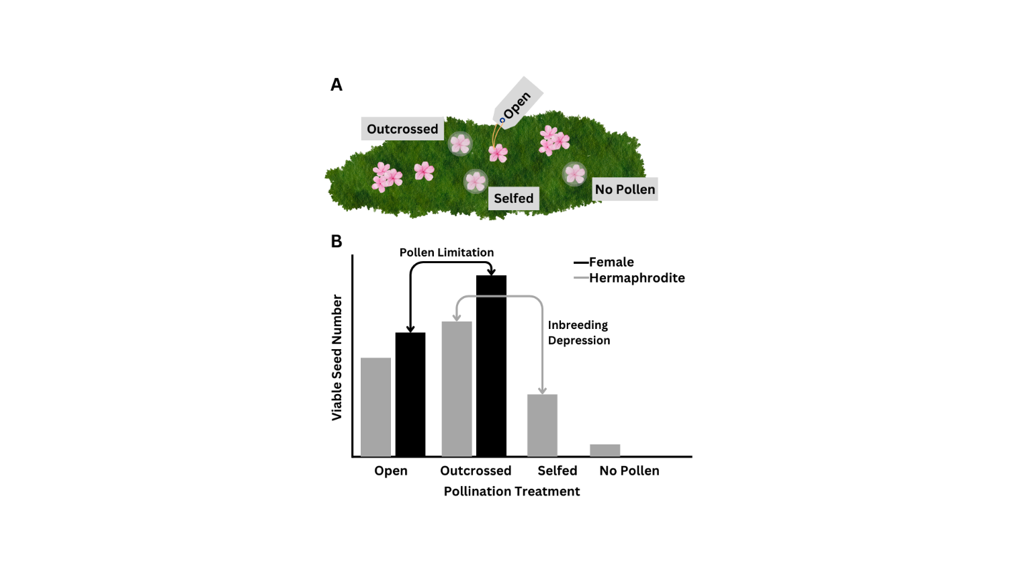

Analysis

*Pre-fertilization*

Floral traits, such as stigma length and ovule number, were analyzed using mixed effects models with the general structure of sex, site, and the interaction between sex and site as fixed effects, and individual plant ID as the random effect. Stigma length was modeled using a linear regression (lmer, *lme4*; (Bates et al. 2015). Due to our interest in the presence of female function and an excess of ovaries with no ovules in our dataset, we used a hurdle model approach for ovule number. Female function was modeled as a binary (with ovules, without ovules) using a generalized mixed effects model with a binomial distribution (glmer, *lme4*). Ovule number, given female function, was modeled using a generalized mixed effects model with a Poisson distribution (glmer, *lme4*).

To test the effect of floral traits and micro sex ratio on pollination, we modeled the pollen count as the binary variable, pollen deposition (pollen deposition, no pollen deposition) and pollen count, given pollen was deposited on the stigma. The general structure for the model included the fixed effects stigma length, micro sex ratio, sex, and site, and the three-way interactions with sex, site and stigma length or micro sex ratio. Plant ID was a random effect in the model. Pollen deposition was modeled using a negative binomial generalized mixed effects model (glmer.nb, *lme4*) and pollen number using a generalized mixed effects model with a Poisson distribution (glmer, *lme4*).

*Post-fertilization*

Fruit set, seed number, seed germination rate, and the cumulative reproductive output were analyzed using generalized linear models. The cumulative reproductive output was calculated by multiplying the fruit set (0,1) by the seed number and germination rate (proportion of seeds from a fruit that germinated). The general model structure included the fixed effects sex, treatment, site, and the interactions between all predictors. Fruit set and the probability that seeds germinated were analyzed using a binomial distribution. Seed number and cumulative reproductive output were analyzed with a Poisson distribution.

All analyses were performed in R 4.4.1.

**Results**

***Pre-fertilization***

*How do floral traits differ between sexes and individuals?*

Females have stigmas that are 1.33 mm longer on average than hermaphrodite stigmas (χ2=46.523, p<0.001). The stigma lengths did not differ across the two populations (χ2=1.411, p=0.235). Individual plants varied in the stigma lengths (χ2=31.866, p<0.001).

The likelihood of producing ovules did not depend on sex (χ2=1.049, p=0.306), but plants from the East Krummholz site were more likely to produce ovules than individuals from the West Knoll site (χ2=6.134, p=0.013). We found that the likelihood of producing ovules was related to stigma length (χ2=43.647, p<0.001). Individuals varied in the mean likelihood of ovule production (χ2=11.592, p<0.001). The interactions between population and stigma length (χ2=9.249, p=0.002) and population and sex (χ2=4.621, p=0.032) were also significant. Some hermaphrodite plants in both populations were functionally male and did not develop ovules in the flowers sampled. One female plant developed no ovules in the two flowers sampled. In flowers with ovules, there were no differences in the number of ovules between the two sexes (χ2<0.001, p=0.984), with increasing stigma length (χ2=1.703, p=0.192), and between the two sites (χ2=0.117, p=0.733).

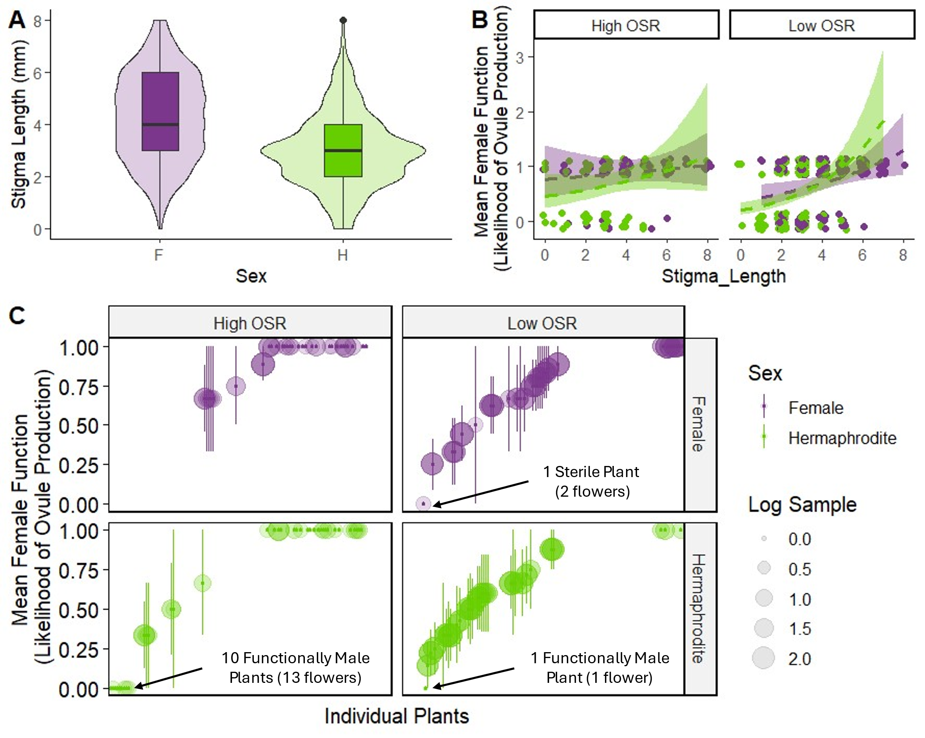

Figure XX. Plant traits in females and hermaphrodites from the East Krummholz and West Knoll sites. Box plot of stigma length (A) showing the median and violin overlay with the density. Average female function, or likelihood of ovule production (B), with error bars showing the standard error. Female function of individual plants (C) with points indicating the mean female function, error bars indicating the standard error, and bubbles indicating the sample size for each individual.

*How do floral traits and micro sex ratio affect pollination?*

The likelihood of receiving pollen depended on the stigma length (χ2=46.666, p<0.001), sex (χ2=20.783, p<0.001), micro sex ratio (χ2=7.414, p=0.006) and the interactions between stigma length and sex (χ2=9635, p=0.002) and population and sex (χ2=5.218, p=0.022). The interaction between stigma length and population was marginally significant (χ2=3.031, p=0.082).

Given that pollen was deposited on the stigma, pollen number depended on stigma length (χ2=18.197, p<0.001), sex (χ2=4.407, p=0.036), and marginally on population (χ2=2.862, p=0.091). The interaction between stigma length and sex (χ2=10.773, p=0.001) and the three-way interaction between stigma length, sex, and population (χ2=4.359, p=0.037) were also significant.

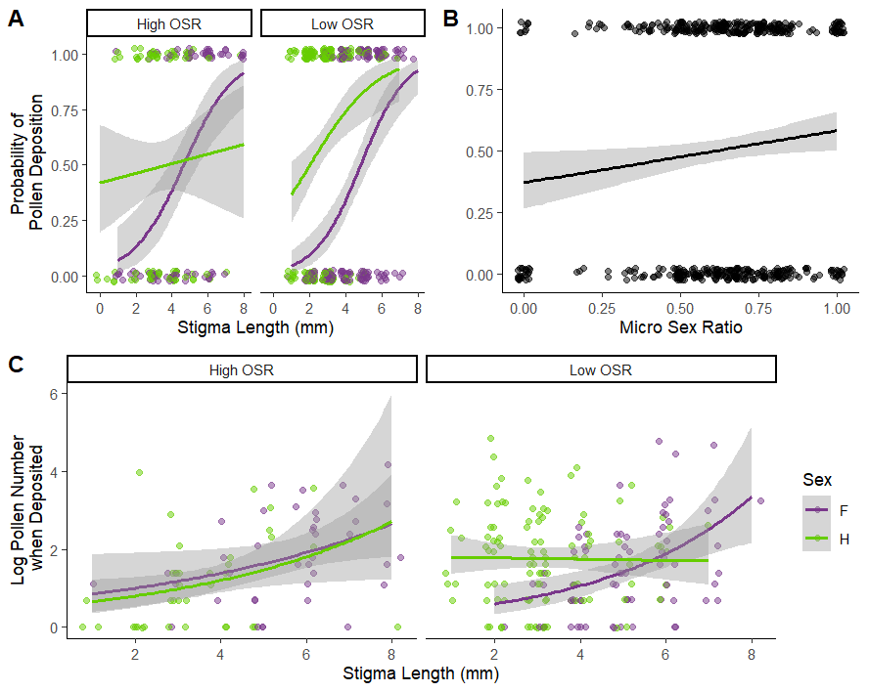

Figure XX. The likelihood of pollen deposition as stigma length (A) and micro sex ratio (B) increase. Given that pollen was deposited on the stigma, the pollen number as stigma length increases (C).

***Post-fertilization***

Table XX. ANOVA table for all models tested in the pollination experiment.

|  |  |  |  |  |  |  |  |  |  |  |  |  |
| --- | --- | --- | --- | --- | --- | --- | --- | --- | --- | --- | --- | --- |
|  | **Fruit Set** | | | **Seed Set** | | | **Seed Germination** | | | **Cumulative Reproductive Output** | | |
| **Term** | χ2 | **dF** | **p** | χ2 | **dF** | **p** | χ2 | **dF** | **p** | χ2 | **dF** | **p** |
| **Sex** | **9.452** | **1** | **0.002** | 2.073 | 1 | 0.150 | **14.139** | **1** | **< 0.001** | 0.077* | 1 | 0.781 |
| **Treatment** | **113.730** | **3** | **< 0.001** | **51.355** | **3** | **< 0.001** | **100.840** | **3** | **< 0.001** | **136.179** | **3** | **< 0.001** |
| **Site** | 2.847 | 1 | 0.092* | 2.009 | 1 | 0.156 | **31.083** | **1** | **< 0.001** | **9.658** | **1** | **0.002** |
| **Sex*Treatment** | **14.317** | **2** | **< 0.001** | 4.804 | 2 | 0.091* | **6.166** | **2** | **0.046** | **7.938** | **2** | **0.019** |
| **Sex*Site** | 0.375 | 1 | 0.540 | **85.291** | **1** | **< 0.001** | **61.853** | **1** | **< 0.001** | **162.211** | **1** | **< 0.001** |
| **Site*Treatment** | 1.469 | 3 | 0.689 | **31.618** | **3** | **< 0.001** | **22.545** | **3** | **< 0.001** | **37.66** | **3** | **< 0.001** |
| **Sex*Treatment*Site** | 2.995 | 2 | 0.224 |  | 0 |  |  | 0 |  |  | 0 |  |

Fruit

The production of fruit was determined by sex, treatment, and the interaction between sex and treatment (Table 1). Site was marginally significant (χ2=2.847, p=0.091). Flowers that were outcrossed were most likely to develop fruits in both sexes. Females had a higher fruit set for the outcrossed treatment (Pairwise comparison; z=3.503, p<0.001), but there was not difference between the sexes in the open pollinated treatment (Pairwise comparison; z=0.015, p=0.988).

Seeds

Only the treatment significantly affected seed number (χ2=51.355, p<0.001). The interactions between sex and population (χ2=85.291, p<0.001) and treatment and population (χ2=31.618, p<0.001) were statistically significant, though. The probability that the seeds germinated did depend on sex (χ2=14.139, p<0.001), treatment (χ2=100.840, p<0.001), and site (χ2=31.083, p<0.001). The interactions between sex and treatment (χ2=6.166, p=0.046) sex and site (χ2=61.853, p<0.001), and treatment and site (χ2=22.545, p<0.001) were all significant. A lack of fruit set in certain treatments impacted the comparisons we could make for seed number and seed germination.

Cumulative Reproductive Output

The cumulative reproductive output (number of viable seeds produced) depended on the treatment (χ2=136.179, p<0.001) and site (χ2=9.658, p=0.002). The interactions between sex and treatment (χ2=7.938, p=0.019), sex and site (χ2=162.211, p<0.001), and treatment and site (χ2=37.660, p<0.001) were also significant.

Inbreeding significantly reduced the reproductive output,

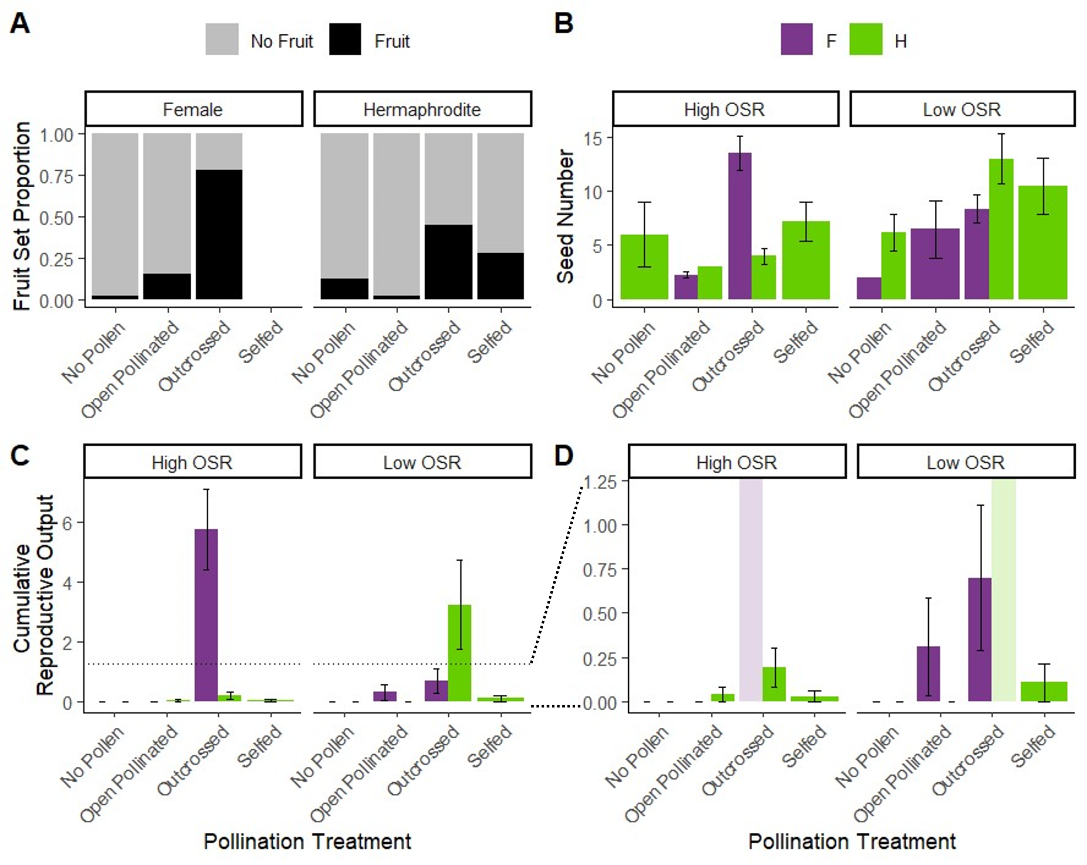

Table XX. Mean and standard deviation of seed production for the outcrossed and open treatment of the pollination treatment for the two populations (high and low OSR) and two sexes (female and hermaphrodite). Pollen limitation is a calculated value describing the pollen limitation from the seed production of the outcrossed and open treatment.

|  |  |  |  |  |  |  |
| --- | --- | --- | --- | --- | --- | --- |
| **Population** | **Sex** | **Outcrossed** | | **Open** | | **Pollen Limitation** |
| **Mean** | **SD** | **Mean** | **SD** |
| High OSR | Female | 10.5 | 8.57 | 0.375 | 0.875 | 3.34 |
| High OSR | Hermaphrodite | 1.58 | 2.50 | 0.125 | 0.612 | 2.54 |
| Low OSR | Female | 6.29 | 6.41 | 0.929 | 2.92 | 1.91 |
| Low OSR | Hermaphrodite | 7 | 9.61 | 0 | 0 | Inf |

**Discussion**

We compared the floral morphology, pollen deposition, and reproductive output for hermaphrodites and females in one low OSR population and one high OSR population in *Silene acaulis*. We found that morphological selective pressures differ for females and hermaphrodites depending on the sex ratio of the site. At the two sites included in this study, pollinators or pollination success is severely limited in both hermaphrodites and females. We found no evidence of frequency dependent selection in the low OSR population. Females were actually less pollen limited in the low OSR population than in the high OSR population.

*Selection for Sexual Dimorphism*

We found selection for sexual dimorphism in two morphological traits- the stigma length and ovule production. Similar to other studies, we found that stigma length was generally longer in females than hermaphrodites (Hermanutz and Innes 1994; Shykoff 1992). Two lines of evidence supported selection on stigma length. Flowers with longer stigmas had a higher likelihood of being pollinated. Pollen capture is more likely and efficient on flowers with longer stigmas (DULBERGER and HOROVITZ 2008). The general trend was consistent among females and hermaphrodites in both the high and low OSR population. However, the strength of the trend differed between the two populations for hermaphrodites. In the low OSR population, hermaphrodites with longer stigmas were much more likely to receive pollen, while in the high OSR population the effect was weaker. Theoretically, hermaphrodites should be less pollen limited in the high OSR population. While there is limited evidence that pollen limitation was stronger in the low OSR population here, multiple generations of low OSR could illicit stronger selection for stigma length because of pollen limitation. Granted, for *Silene acaulis* the historical environment under which selection acted can be centuries ago, when pollinator prevalence and resource availability may have differed substantially.

Similar to Hermanutz and Innes (1994), we found that stigma length was related to the likelihood of producing ovules. Individuals with ovules were more likely to have longer stigmas. This may relate the potential for ovule fertilization for space for pollen deposition on the stigmatic surface. Ovaries lacking ovules or ovules that were aborted early was common among flowers on *S. acaulis* plants on both sexes, but more common on hermaphrodites. Hermanutz and Innes (1994) also found that degenerative ovules in hermaphrodites generally occurred in flowers with shorter styles. The style length was also related to fruit set. Hermanutz and Innes (1994) found that hermaphrodites with long stigmas had 100% fruit set in all populations, but flowers with medium and especially short length styles had reduced fruitset.

In our study, the divide between hermaphrodites with normal and degenerated ovules was most compelling for the high OSR population, where all flowers collected on 10 plants had ovaries without ovules. While the high OSR population seemed to have more of a bimodal shape, plants in the low OSR population had a greater variance in the likelihood of ovule production among individuals. This may suggest a functional divide between the hermaphrodites in populations where “male” competition is theoretically higher. Hermaphrodites that either produce and develop ovules for female function and those that do not. The link to stigma length also indicates a potential reduction in structures related to female function. The maintenance of high OSR populations, but with a stable frequency of females could favor the introduction of female-sterile morphs that exhibit a “male” character, resulting in a trioecious evolutionary trajectory.

Subspecies of *Silene acaulis* in Europe have been identified as trioecious (Maurice et al. 1998). Plants designated “male” are identified by having straight, reduced styles that do not surpass the mouth of the corolla. However, Maurice et al. (1998) found half the individuals designated “male” based on style length morphology set fruit, while a third of “hermaphrodites” in their study did not set fruit. The shift to trioecy seems incomplete in Europe and of a similar nature in North America. While unexplored in the paper, they reported the sex ratios in the several populations of both *S. a. exscapa* and *S. a. cenisia* where they examined fruit set. Based on a rough analysis of their results, the proportion of hermaphrodites with functionally male character increases with OSR (Maurice et al. 1998). These results support the potential connection between operational sex ratio and an increase in strictly “male” function in hermaphrodites. This likely has to do with the increase in hermaphrodite competition as hermaphrodite frequency increases. Selection for allocation to male function may increase the fitness in a population dominated by hermaphrodites that still allocate resources to female function.

Canelles et al. (2018) hypothesized that sexual dimorphism and reproductive compensation is modulated by environment. They proposed that climate severity may promote resource allocation toward just male function in hermaphrodites. However, they found no evidence for this hypothesis. If sex ratio is really what modulates sexual dimorphism and reproductive output, then there may be an indirect interaction between environment and macroevolution in *S. acaulis*. Alatalo and Molau (1995) found that the sex ratio becomes more female-biased at high elevations in Norway. Similarly, Svoen et al. (2019) found that female frequency increased with latitude in Sweden. We have also established that female frequency increases with elevation in the Colorado Rockies and latitude based on a citizen science dataset (Chandler and DeMarche Unpublished Data).

*Female Compensation*

Similar to Canelles et al. (2018), we found limited evidence that seed set differs substantially between females and hermaphrodites, but fruit set was a different story. Females had superior fruit set for both open and outcrossed treatments in our pollination experiment.

*Consequences of Pollen Limitation?*

Contrary to what others found, pollen deposition did depend on the sex of the individual (Shykoff 1992). Both likelihood of pollination and the number of pollen grains was higher in

Theoretically, pollen limitation should favor hermaphrodites in a population. As hermaphrodites become less common, pollen should be more limited and confer a fitness advantage to any pollen producing individuals (Delph et al. 2007; Saur Jacobs and Wade 2003). While hermaphrodites were limited in our low OSR population relative to the high OSR population, females were less pollen limited according to the pollination experiment. One explanation might be that micro-habitat sex ratio is more important than broad, population-level sex ratio. As the micro sex ratio increased, both female and hermaphrodite individuals were more likely to have pollen deposited on their stigmas. Regardless of the population OSR and sex, reproductive output from open pollination was severely low. Lack of pollinators is likely the limiting factor, rather than a lack of mates. Alpine environments are generally lacking in pollinators, compared to lower elevation sites CITATION. *Is this circular logic…* The lack of pollen limitation in the low OSR population relative to hermaphrodites and the high OSR population may be one of the contributing factors allowing females to persist at higher frequencies in the low OSR population.

The low OSR population was at a higher elevation (+500 feet) on a more exposed, south facing aspect, while the high OSR population was adjacent to krummholz, in a less exposed, east facing aspect. Anecdotally, the high OSR population was denser than the low OSR population. It is possible that reproductive output and pollen limitation depends on the interaction between plant density and sex ratio.

*Limitations*

Our inferences are mostly limited by the lack of replication in this study. We only compared females and hermaphrodites in one low and one high OSR population. Thus, the scope of this study cannot provide broad implications for how low and high OSR populations generally behave in *S. acaulis* and other gynodioecious species. Furthermore, to really establish a shift toward more “male” character, we must also consider the pollen production in hermaphrodites.

We find similar patterns to those previously published in *Silene acaulis* but add the population-level and micro-level sex ratio as potential drivers of dimorphic selection. These findings are the beginning steps to bridging the gap between population-level behaviors and sexual selection that describe the transition from sub dioecy toward dioecy. Populations of *S. aculis* vary substantially in sex ratio as Hermanutz and Innes (1994) reported OSRs as low as 0.2 and as high as 1 as reported in Maurice et al. (1998). This variability in sex ratio provides a landscape of variable selective environments, and particularly through intraspecific competition. We find that increased competition among hermaphrodites in a high OSR population may drive the increase of “male” character among individuals. While not a new concept, even in *S. acualis*, this study is the first to link sex ratio to interactions between the sexes in populations.

Dimorphic floral traits, particularly in female function suggest the potential that *Silene acaulis* in the Colorado Rocky Mountains may be transitioning to a trioecious mating system.

Key Results

*Pre-fertilization*

1. Stronger selection for longer stigmas in females
2. Selection for longer stigmas (female resource allocation) in both sexes when pollen is limited
   1. Is b. true when pollen number does not depend on stigma length?
   2. Female stigmas are longer than hermaphrodites and as the stigma length increases, pollen deposition on the stigma increases likelihood and number. When there are fewer hermaphrodites in a population, the likelihood of pollen deposition also increases with stigma length in hermaphrodites, but the number of pollen grains is not affected.
3. Hermaphrodites may be functionally male or at least produce a proportion of flowers that are functionally male and this is more likely when hermaphrodites are more common.
4. More resources are allocated to female function when there are more hermaphrodites in a population and potentially less pollen limitation. (rephrase)
   1. The likelihood of producing ovules is higher in females than hermaphrodites. Both sexes have a higher likelihood of producing ovules in the high OSR population. Hermaphrodite individuals had a higher likelihood of producing multiple flowers with no ovules.
   2. Both sexes vary in female function
      1. Both female and males produce flowers without ovules
5. Chances of pollination for either sex increases as the number of nearby hermaphrodites increases.
6. Hermaphrodites have a pollen availability advantage in pollen limited (low hermaphrodite) environments.
   1. The likelihood of pollen deposition increased as the number of hermaphrodite plants surrounding the focal plant increased. Hermaphrodites had a higher chance of having pollen deposited on stigmas in the low OSR population, while females had a slightly higher chance in the high OSR population.

*Post-fertilization*

1. Hermaphrodites and females are pollen limited in both high and low OSR populations.
   1. The open pollinated treatment rarely produced seeds and the germination rates for those seeds were low.
2. Reproductive output depends on the sex ratio of the population.
   1. Females have a higher reproductive output in high OSR populations, but the opposite is true for low OSR populations, when pollen was supplemented.
3. Inbreeding depression affects the reproductive output of hermaphrodites.
   1. While hermaphrodites that are geitonogamously pollinated produce as many or more seeds, the germination rate is low. The same is true for seeds that were fertilized from pollen on the same flower or autogamous pollinated.

Alatalo, J.M., and Molau, U. 1995. Effect of altitude on the sex ratio in populations of Silene acaulis (Caryophyllaceae). Nordic Journal of Botany **15**(3): 251-256. doi:10.1111/j.1756-1051.1995.tb00150.x.

Alonso, C. 2005. Pollination success across an elevation and sex ratio gradient in gynodioecious Daphne laureola. American Journal of Botany **92**(8): 1264-1269. doi:10.3732/ajb.92.8.1264.

Asikainen, E., and Mutikainen, P. 2003. Female frequency and relative fitness of females and hermaphrodites in gynodioecious Geranium sylvaticum (Geraniaceae). American Journal of Botany **90**(2): 226-234. doi:10.3732/ajb.90.2.226.

Bates, D., Maechler, M., Bolker, B., and Walker, S. 2015. Fitting Linear Mixed-Effects Models Using lme4. Journal of Statistical Software **67**(1): 1-48. doi:10.18637/jss.v067.i01.

Canelles, Q., Saura-Mas, S., Brotons, L., García, M.B., Lloret, F., Villellas, J., and Morris, W.F. 2018. Environmental stress effects on reproduction and sexual dimorphism in the gynodioecious species Silene acaulis. Environmental and Experimental Botany **146**: 27-33. doi:10.1016/j.envexpbot.2017.06.010.

Charlesworth, B., and Charlesworth, D. 1978. A Model for the Evolution of Dioecy and Gynodioecy. The American Naturalist **112**(988): 975-997.

Charlesworth, D. 1981. A further study of the problem of the maintenance of females in Gynodioecious species. Heredity **46**(1): 27-39. doi:10.1038/hdy.1981.3.

Delph, L., Touzet, P., and Bailey, M. 2007. Merging theory and mechanism in studies of gynodioecy. Trends in Ecology & Evolution **22**(1): 17-24. doi:10.1016/j.tree.2006.09.013.

Delph, L.F., and Carroll, S.B. 2001. Factors affecting relative seed fitness and female frequency in a gynodioecious species, Silene acaulis [Periodical]. Evolutionary Ecology Research **3**(4): 487-505.

DULBERGER, R., and HOROVITZ, A. 2008. Gender polymorphism in flowers of Silene vulgaris (Moench) Garcke (Caryophyllaceae). Botanical Journal of the Linnean Society **89**(2): 101-117. doi:10.1111/j.1095-8339.1984.tb01004.x.

Field, D.L., Pickup, M., and Barrett, S.C.H. 2013. COMPARATIVE ANALYSES OF SEX-RATIO VARIATION IN DIOECIOUS FLOWERING PLANTS. Evolution **67**(3): 661-672. doi:10.1111/evo.12001.

Hermanutz, L.A., and Innes, D.J. 1994. Gender variation in Silene acaulis (Caryophyllaceae) [research-article]. Plant Systematics and Evolution **191**(1/2): 69-81.

Lloyd, D.G. 1974. Theoretical sex ratios of dioecious and gynodioecious angiosperms. Heredity **32**(1): 11-34. doi:10.1038/hdy.1974.2.

Maurice, S., Desfeux, C., Mignot, A., and Henry, J.P. 1998. Is Silene acaulis (Caryophyllaceae) a trioecious species? Reproductive biology of two subspecies [Journal Article]. Canadian Journal of Botany **76**(3): 478-485. doi:10.1139/cjb-76-3-478.

Morris, W.F., and Doak, D.F. 1998. Life history of the long‐lived gynodioecious cushion plant <i>Silene acaulis</i> (Caryophyllaceae), inferred from size‐based population projection matrices. American Journal of Botany **85**(6): 784-793. doi:10.2307/2446413.

Saur Jacobs, M., and Wade, M.J. 2003. A Synthetic Review of the Theory of Gynodioecy [research-article]. The American Naturalist **161**(6): 837-851. doi:10.1086/375174.

Shykoff, J.A. 1992. SEX POLYMORPHISM IN SILENE ACAULIS (CARYOPHYLLACEAE) AND THE POSSIBLE ROLE OF SEXUAL SELECTION IN MAINTAINING FEMALES. American Journal of Botany **79**(2): 138-143. doi:10.1002/j.1537-2197.1992.tb13630.x.

Shykoff, J.A., Kolokotronis, S.-O., Collin, C.L., and López-Villavicencio, M. 2003. Effects of male sterility on reproductive traits in gynodioecious plants: a meta-analysis. Oecologia **135**(1): 1-9. doi:10.1007/s00442-002-1133-z.

Svoen, M.E., Muller, E., Brysting, A.K., Kalas, I.H., and Eidesen, P.B. 2019. Female advantage? Investigating female frequency and establishment performance in high-Arctic Silene acaulis [Report]. Botany **97**(4): 245. doi:10.1139/cjb-2018-0150.